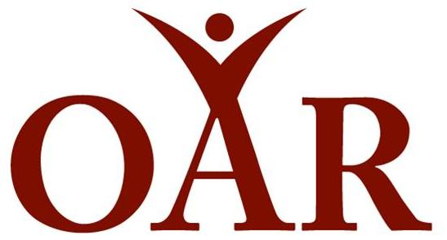

Strengthening Community Through Second Chances

BOARD MEMBER
Position Description

Background: Offender Aid and Restoration of Arlington County Inc (OAR), a community based nonprofit organization, believes in second chances. OAR has been serving Arlington County and the Cities of Alexandria and Falls Church since 1974. OAR works alongside justice involved individuals and those affected by the criminal justice system. Our participants are individuals who are currently incarcerated, were recently released from incarceration, and/or are completing court-mandated community service, as well as their families. OAR is also part of the public safety family and partners with the Arlington County and City of Alexandria Government, Arlington and Alexandria Sheriff’s Office, Arlington and Alexandria Probation and Parole Officers, Virginia Department of Corrections, Virginia Criminal Justice Services, and safety-net nonprofits, among other stakeholders, to ensure a thriving community.

Vision: OAR envisions a safe and thriving community where those impacted by the criminal justice system enjoy equal civil and human rights.

More information may be found at www.OARonline.org

Position: The Board will support the work of OAR and provide mission-based leadership and strategic governance. While day-to-day operations are led by OAR’s chief executive officer (CEO), the Board-CEO relationship is a partnership, and the appropriate involvement of the Board is both critical and expected. Specific Board Member responsibilities include:

Leadership, governance and oversight
- Serving as a trusted advisor to the CEO as she develops and implements OAR’s strategic plan
- Reviewing outcomes and metrics created by OAR for evaluating its impact, and regularly measuring its performance and effectiveness using those metrics; reviewing agenda and supporting materials prior to board and committee meetings
- Approving OAR’s annual budget, audit reports, and material business decisions; being informed of, and meeting all, legal and fiduciary responsibilities
- Contributing to an annual performance evaluation of the CEO
- Assisting the CEO and board chair in identifying and recruiting other Board Members
- Partnering with the CEO and other board members to ensure that board resolutions are carried out
- Serving on committees or task forces and taking on special assignments
- Representing OAR to stakeholders; acting as an ambassador for the organization
- Ensuring OAR’s commitment to a diverse board and staff that reflects the communities OAR serves

Fundraising
- OAR Board Members will consider OAR a philanthropic priority and make annual gifts that reflect that priority. So that OAR can credibly solicit contributions from foundations, organizations, and individuals, OAR expects to have 100% of Board Members make an annual contribution that is commensurate with their capacity.

Board terms/Participation

OAR’s Board Members will serve a two-year term to be eligible for re-appointment for an additional term(s). Board meetings are held on the third Wednesday of every other month from 5:30pm to 8:30pm. Board Members are asked to attend the board meetings, serve on one of the board committees/taskforces, financially support the work of OAR, attend OAR events, attend community events as a representative for OAR, and participate as a table captain at our annual Second Chance Fundraising breakfast.
Qualifications
This is an extraordinary opportunity for an individual who is passionate about OAR’s mission and who has a track record of supporting community organizations. Selected Board Members will have achieved leadership stature in business, government, or the nonprofit sector. His/her accomplishments will allow him/her to attract other well-qualified, high-performing Board Members.
Ideal candidates will have the following qualifications:
- Lives or works in Northern Virginia
- Strong personal commitment to the mission of OAR
- Willingness and ability to speak about issues facing those returning from incarceration
- Natural affinity for cultivating relationships and soliciting individual, foundation, and/or corporate donations (either funding or in-kind donation support)
- Embrace the OAR team values of Justice, Community, Commitment, Compassion, Respect, and Integrity
- Ethical, credible, and a passion for improving the lives of OAR’s participants
- Experience in financial management, business development, or legal services preferred
If you are interested in learning more about joining OAR’s Board, please contact Ann Springer, Board Governance Chair, at ann.springer@verizon.net and Elizabeth Jones Valderrama, OAR Executive Director, at ejones@oaronline.org.

